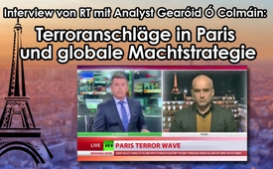
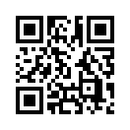
RT - Interview with analyst Gearoid O’Colmain: Terror attacks in Paris and global power strategy
In an interview with Russia Today (RT) the independent analyst and author Gearóid Ó Colmáin presents his view on the attacks of Paris. He is convinced that a targeted propaganda campaign is going on in order to stir up fear of Muslims and civil wars in Europe.
In an interview with Russia Today (RT) the independent analyst and author Gearóid Ó Colmáin presents his view on the attacks of Paris. He is convinced that a targeted propaganda campaign is going on in order to stir up fear of Muslims and civil wars in Europe. He calls the war against terror a war against the population which is “orchestrated from abroad”. He says the target of the desired total destabilization is the creation of a new global order to the benefit of a small elite only. In this context Colmáin anticipates a persecution by governmental-medial propaganda campaigns against critics of the political system, those who think differently and alternative media. This - in order to stop them from publicly voicing their opinion which doesn't match the governmental course or policy. This way the population is to be hindered to ask critical questions. Following now, we will show Russia Today's complete interview with Gearóid Ó Colmáin.
from hm.
Sources:
https://www.youtube.com/watch?v=L7GAbVhjTSw
This may interest you as well:
---
Kla.TV – The other news ... free – independent – uncensored ...
- what the media should not keep silent about ...
- Little heard – by the people, for the people! ...
- regular News at www.kla.tv/en
Stay tuned – it’s worth it!
Free subscription to our e-mail newsletter here: www.kla.tv/abo-en
Security advice:
Unfortunately countervoices are being censored and suppressed more and more. As long as we don't report according to the ideology and interests of the corporate media, we are constantly at risk, that pretexts will be found to shut down or harm Kla.TV.
So join an internet-independent network today! Click here: www.kla.tv/vernetzung&lang=en
Licence: Creative Commons License with Attribution
Spreading and reproducing is endorsed if Kla.TV if reference is made to source. No content may be presented out of context.
The use by state-funded institutions is prohibited without written permission from Kla.TV. Infraction will be legally prosecuted.

