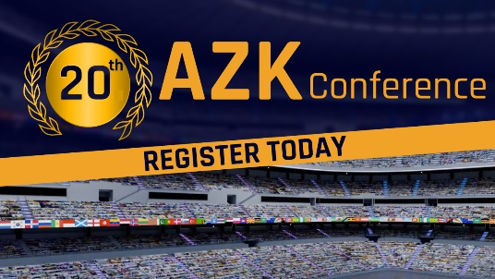
20th AZK Conference! Summer is not just about soccer! – REGISTER TODAY

AZK invites you to its anniversary conference this summer! AZK – Anti-Censorship Coalition is one of Europe‘s largest platforms for free information. Versatility guaranteed: All speakers are prominent experts in their field. The AZK is a place where new hope is born, new courage and heartfelt solidarity: meet like-minded people from your region at the 20th AZK! Register today at: www.anti-zensur.info/azk20 – We will tell you when and where you can take part in your area! – All free of charge.
Summer has more to offer than soccer! AZK invites you to its anniversary conference this summer!
20TH AZK
one of Europe‘s largest platforms for free education since 2008.
Get in touch with us! We will tell you when and where you can participate in your area!
REGISTER HERE: www.anti-zensur.info/azk20
Top-class speakers will give an update on the current world situation at the anniversary conference. Versatility guaranteed: All speakers are prominent experts in their field
As usual, the choice of speakers will be a surprise. This much we can reveal: It will be diverse, international and worthy of an anniversary conference! Ivo Sasek, the founder of the AZK, will host the conference and a varied music program will frame the day.
Simultaneous translation into various languages.
All-day event – all free of charge, including catering.
AZK visitors:
“I am impressed every time and go home with goosebumps and palpitations.”
“The lectures are very interesting and really necessary in this day and age!”
“Everything is really represented here [...] This “left – right” scheme, which is imposed on us by a small clique, is completely outdated.”
Register today at: www.anti-zensur.info/azk20
You will be informed of the date and participation options by an AZK coworker from your area! Meet like-minded people from your area at the 20th AZK! – 20th AZK – A unique opportunity – an international highlight!
“I had to get so old to experience something like this! Thank you for that!”
from es.

Register today at: www.anti-zensur.info/azk20

This may interest you as well:
#IvoSasek-en - Ivo Sasek - www.kla.tv/IvoSasek-en
#AZK-en - AZK - www.kla.tv/AZK-en
Kla.TV – The other news ... free – independent – uncensored ...
- what the media should not keep silent about ...
- Little heard – by the people, for the people! ...
- regular News at www.kla.tv/en
Stay tuned – it’s worth it!
Free subscription to our e-mail newsletter here: www.kla.tv/abo-en
Security advice:
Unfortunately countervoices are being censored and suppressed more and more. As long as we don't report according to the ideology and interests of the corporate media, we are constantly at risk, that pretexts will be found to shut down or harm Kla.TV.
So join an internet-independent network today! Click here: www.kla.tv/vernetzung&lang=en
Licence: Creative Commons License with Attribution
Spreading and reproducing is endorsed if Kla.TV if reference is made to source. No content may be presented out of context.
The use by state-funded institutions is prohibited without written permission from Kla.TV. Infraction will be legally prosecuted.

