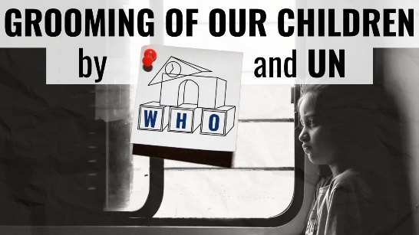
Comic: Grooming of our Children by WHO and UN
“Once upon a time, biology classes were limited to anatomical differences and how babies are made. Not quite up to date? That’s what the WHO thought...”
Once upon a time, biology classes were limited to anatomical differences and how babies are made, what to do if you’re not ready for them, and how to protect yourself from unwanted diseases. Not quite up to date?
That’s what the WHO, the World Health Organization, thought and came up with standards that, together with the Federal Center for Health Education in Germany, morphed into an education plan. However, the WHO standards are to be enforced throughout Europe across all subjects.
This affects over 15.6 million children in German-speaking countries alone, who will be trained in the use of dildos, love balls, leather whips or handcuffs in the future. Where does which object fit, how do I set up a brothel, which does justice to all people of all sexual inclinations, are the tricky tasks the children may face.
The boring often soporific nature movies in class are to be replaced by viewing porn and pornographic images to teach responsible use. This applies to students 12 years and older.
What a little boy doesn’t learn, a big boy won’t catch-up on.
That is why the WHO proposes early sexual education in kindergarten and elementary school. Mutual touching and doctor games are supposed to teach children about external differences. Everything about early childhood masturbation and the desire to discover one’s own body and genitals and other questionable content can be read in the WHO standards.
Who is behind the implementation of these innovative ideas?
As far as Germany is concerned, the five authors of the practical book Sexual Pedagogy of Diversity, which is to be used for teaching, belong to the German Society for Sexual Pedagogy and its affiliated institute, which, according to its own definitions, awards the seal of quality for sexual pedagogy.
The co-founder and mentor is Uwe Sielert, professor of education in Kiel, Germany.
Sielert is the facilitator of a gender-sex pedagogy with which he aims to de-naturalize three life circumstances:
- The traditional family,
- The heterosexuality
- and Generativity.
The gender program can be read in the information service of the Federal Center for Health Education. The gender ideology behind the sexual education of diversity is explosive, but not new, even if it is only now spilling into our schools. It achieved its breakthrough as early as 1995 in Beijing. In her book, “The Gender Agenda”, participant Dale O’Leary summarized five theses that have majority support in the UN establishment.
Item three on the list is: the world needs sex education for children and young people that encourages sexual experimentation; it needs the abolition of parental rights. Good things take time, and here we are. Those who do not approve of this type of teaching for their child will soon find themselves in a quandary: In Germany staying away from class is punishable by law, which also gives parents the opportunity to become acquainted with handcuffs used by their children in class.
Even if it seems absurd, it is a reality.
from ts.
UN on „Consentual Sex“ with Minors (see Principle 16)
https://share-netinternational.org/wp-content/uploads/2023/03/8-MARCH-Principles-FINAL-printer-version-1-MARCH-2023.pdf
Standards for Sexuality Education in Europe (BZgA)
https://www.bzga-whocc.de/fileadmin/user_upload/BZgA_Standards_English.pdf

Sources:
Grooming of our Children by WHO and UN
https://rumble.com/v3n4xma-zugriff-auf-unsere-kinder-durch-die-who-und-un.html
UN on „Consentual Sex“ with Minors (see Principle 16)
https://share-netinternational.org/wp-content/uploads/2023/03/8-MARCH-Principles-FINAL-printer-version-1-MARCH-2023.pdf
Standards for Sexuality Education in Europe (BZgA)
https://www.bzga-whocc.de/fileadmin/user_upload/BZgA_Standards_German.pdf
This may interest you as well:
#WHO-en - World Health Organization - www.kla.tv/WHO-en
#UN-en - UN - www.kla.tv/UN-en
Kla.TV – The other news ... free – independent – uncensored ...
- what the media should not keep silent about ...
- Little heard – by the people, for the people! ...
- regular News at www.kla.tv/en
Stay tuned – it’s worth it!
Free subscription to our e-mail newsletter here: www.kla.tv/abo-en
Security advice:
Unfortunately countervoices are being censored and suppressed more and more. As long as we don't report according to the ideology and interests of the corporate media, we are constantly at risk, that pretexts will be found to shut down or harm Kla.TV.
So join an internet-independent network today! Click here: www.kla.tv/vernetzung&lang=en
Licence: Creative Commons License with Attribution
Spreading and reproducing is endorsed if Kla.TV if reference is made to source. No content may be presented out of context.
The use by state-funded institutions is prohibited without written permission from Kla.TV. Infraction will be legally prosecuted.

